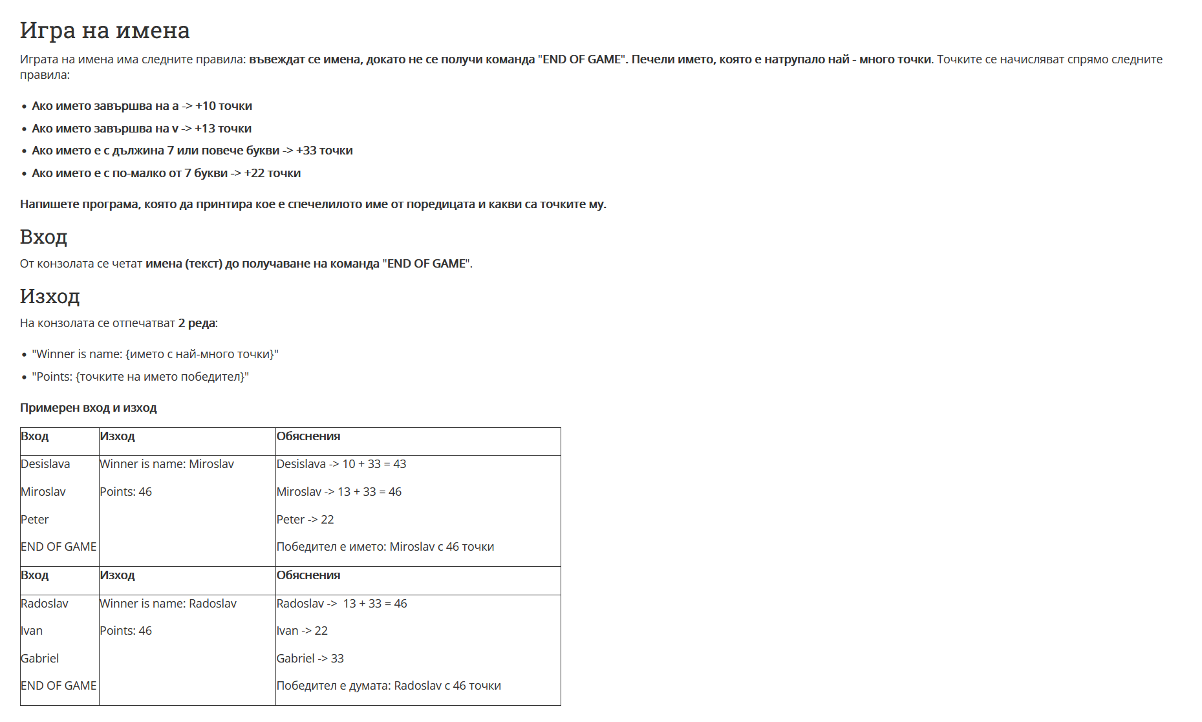

using System;

using System.Collections.Generic;

namespace ConsoleApp245

{

class Program

{

static void Main(string[] args)

{

bool checkForStop = true;

var namesWithSoccer = new Dictionary<string, int>();

while (checkForStop)

{

string name = Console.ReadLine();

if (name == "END OF GAME")

{

checkForStop = false;

}

else

{

char[] names = name.ToCharArray();

int currentResult = 0;

if (names[names.Length - 1] == 'a')

{

currentResult += 10;

}

else if (names[names.Length - 1] == 'v')

{

currentResult += 13;

}

if (names.Length >= 7)

{

currentResult += 33;

}

else

{

currentResult += 22;

}

if (!namesWithSoccer.ContainsKey(name))

{

namesWithSoccer.Add(name ,currentResult);

}

}

}

PrintNameWithMaxPoints(namesWithSoccer);

}

private static void PrintNameWithMaxPoints(Dictionary<string, int> namesWithSoccer)

{

List<int> results = new List<int>();

foreach(var name in namesWithSoccer)

{

results.Add(name.Value);

}

int maxRes = int.MinValue;

for (int i = 0; i < results.Count; i++)

{

if (results[i] > maxRes )

{

maxRes = results[i];

}

}

foreach (var name in namesWithSoccer)

{

if (name.Value == maxRes )

{

Console.WriteLine($"Winner is name: {name.Key}");

Console.WriteLine($"Points: {maxRes}");

}

}

}

}

}